# House Sales in King County, USA

## Data Sourcing

## This data is publicly available open-source data. It was downloaded from Kaggle.com.

## [House Sales in King County, USA | Kaggle](https://www.kaggle.com/datasets/harlfoxem/housesalesprediction)

## Data Content:

* This dataset contains house sale prices for King County, which includes Seattle. It includes homes sold between May 2014 and May 2015.

## Data Relevance

## This data is relevant and crucial to answer the questions of this project.

## Why I chose this data.

* I chose this data as I gave not done retail data.

Data Cleaning

* deleted longitude and latitude to protect location and address
* Price column: convert format to 2 decimal places
* Deleted duethis information is not important to data analysissqft_living15 - The square footage of interior housing living space for the nearest 15 neighbors  
  sqft_lot15 - The square footage of the land lots of the nearest 15 neighbors.
* Convert dates to dd-mm-yy and remove time
* Check for missing data
* Check for duplicate data
* Check for mixed data type

Meanings of columns

* sqft_lot - Square footage of the land space
* view - An index from 0 to 4 of how good the view of the property was
* condition - An index from 1 to 5 on the condition of the apartment
* grade - An index from 1 to 13, where 1-3 falls short of building construction and design, 7 has an average level of construction and design, and 11-13 have a high quality level of construction and design.

**Consider limitations and ethics**

* Some of the columns have an index that will need to be reported in the data so anyone looking at it can understand the numbers represent.
* The data has zip code and longitude and latitude, deleted longitude and latitude to protect location and address.

Data Profile

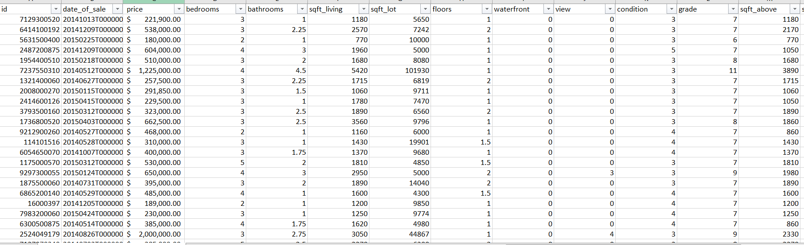

**Define questions to explore**

* Characteristics of the most expensive houses.
* Does the year of renovation have an impact on sales price, ex. Renovated in 2015 vs 1950.
* Of the following waterfront, view, condition, and grade have the highest impact on sale price.